Draft 1：

While copying Karl Nawrot’s Mona typeface using Glyphs, I became less interested in the visual appearance of the letters and more focused on how the typeface is constructed through the tool. Rather than being individually drawn forms, the letters are assembled from a limited set of recurring elements. These elements adjust their thickness, scale, and shape depending on context in order to maintain legibility, suggesting that legibility is not fixed but actively negotiated within the system.
Through this process, I noticed that the intersections between elements create a clear sense of spatial relationship. The strokes appear to have front and back positions, forming a layered structure rather than a flat graphic surface. This spatial quality became especially apparent through Glyphs, where strokes are drawn with direction and order. Compared to Illustrator, Glyphs feels closer to a writing process, where the sequence and direction of strokes matter, and where overlaps reveal how the letter is constructed over time. Unexpectedly, these overlaps also made the design process itself more readable, allowing me to clearly see how each element functions within the letter.
This led me to ask whether letters can be understood as spatial structures rather than purely graphic forms, and how changes in spatial relationships might affect legibility. To explore this further, I propose a studio-based experiment that iteratively alters stroke direction, layering, and spatial rules within the same type system, observing how these changes influence both structure and readability without assuming a fixed outcome.

Draft 2:
Background

This project started by copying the typeface Mona using Glyphs. While doing this, I realised that the letterforms are not drawn as single, finished shapes. Instead, they are built from a small set of repeated elements, organised through stroke order, direction, and overlap. Even though the typeface exists within a two-dimensional system, these relationships already create a sense of depth.

This led me to shift my focus away from questions of legibility or stylistic expression. Instead, I became interested in how two-dimensional visual systems are able to suggest three-dimensional space, and whether this sense of depth comes from the forms themselves or from the rules and processes that generate them.

Conditional Design as a Lens

To develop this enquiry, I turned to the Conditional Design Manifesto, which understands design as the construction of conditions rather than the production of fixed outcomes. It emphasises working with rules, iteration, and systems, where form emerges through process instead of individual aesthetic choices.

Through this lens, I began to think about typography not as a set of visual shapes, but as a system with its own internal logic. From this perspective, spatial depth is not something added visually to letters. Instead, it emerges from conditions such as order, direction, and constraint.

Applying Conditional Thinking to the Practice

Using this approach, I translated the typographic system into a three-dimensional environment. Rather than modelling complete letters, I modelled each stroke separately and assembled them according to the same structural logic identified during the copying process. This made the internal construction of the letters easier to read when viewed from different angles.

From there, the focus moved away from the letterforms themselves and toward how they interact with space. Simple geometric forms were introduced as obstacles, including a sphere, cube, cylinder, and cone. A fixed light source was used, while distance and viewing angle were adjusted in a controlled way. Each experiment changed only one variable at a time, allowing the spatial effects to be observed through projection and shadow.

Advancing the Enquiry

Seen through the lens of Conditional Design, these experiments are not about creating new typographic forms. Instead, they aim to reveal the spatial assumptions already present within a two-dimensional system. The outcomes are not single images, but a series of variations that show how depth is produced through interruption, overlap, and spatial ordering.

Rather than working toward a final visual result, the project treats iteration as the main method of enquiry. Through this process, text shifts from being stable graphic information to something that is continuously reshaped by spatial conditions. This allows typography to be understood as a system that can engage with space, where meaning and form emerge through rules, repetition, and context.

Draft3: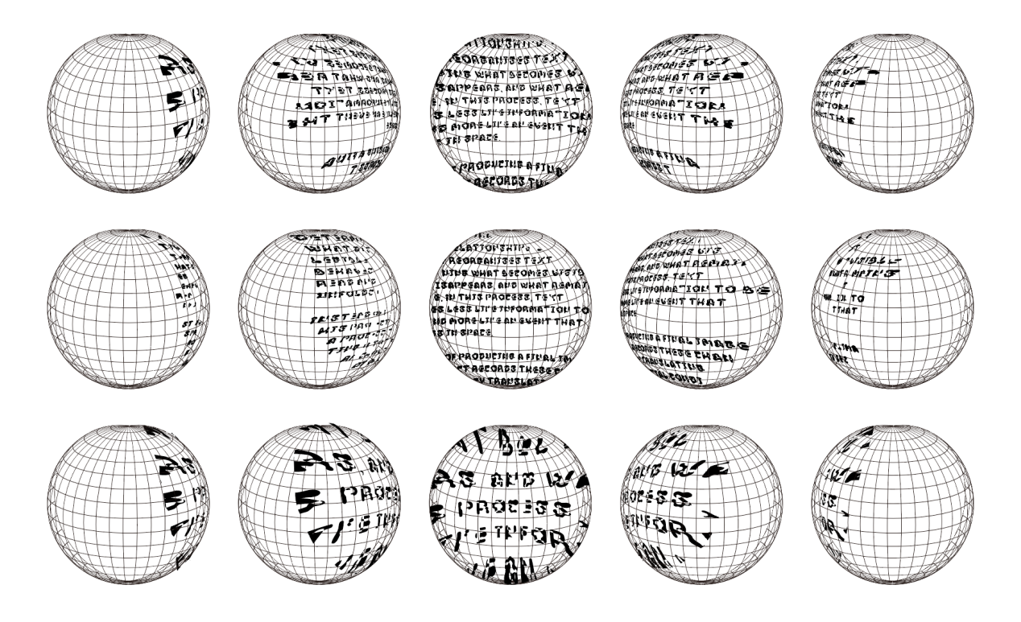
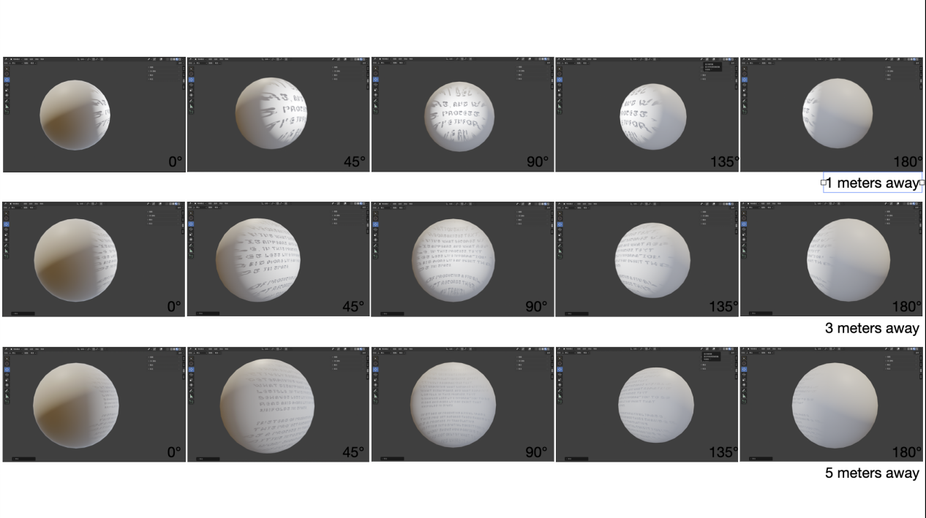
In the experiments, the same text is placed behind simple geometric objects and projected under fixed light conditions. By changing distance and angle, the shadow of the text shifts, breaks apart, or overlaps. These changes are not visual effects added afterwards, but direct results of the spatial setup.

The experiments suggest that depth does not originate from form alone, but from relationships. Space actively reorganises text, determining what becomes visible, what disappears, and what remains legible. In this process, text behaves less like information to be read and more like an event that unfolds in space.

Instead of producing a final image, this project records these changes as a process. By translating writing into spatial conditions, the work shows how meaning can be affected not only by what text says, but by how and where it appears.

